***Deals on Wheels: let the market show you how to buy a better car  
(Alternative title)***

Michael A. Boles

March 2020

**Executive summary**

This article describes the collection and modeling of new and used car prices. Approximately 100,000 listings were scraped from Autotrader, an online vehicle marketplace, in January 2020. From this data set, empirical depreciation curves were constructed for several hundred car models, enabling comparison of value retention across car brands, body styles, and listing locations. Depreciating faster than average are luxury cars, electric vehicles (EVs), and cars listed in areas with large seasonal temperature variation. At the other end, Japanese/Korean brands, trucks, and iconic cars were found to retain value better than most. The pricing model, an exponential fit of list price versus age, tracks car value well across most of the life cycle, but generally underestimates depreciation in year one and overestimates it in years 15+. Importantly, the empirical depreciation rates obtained from this work offer a crowdsourced metric of the pleasure or pain that accompanies ownership of a particular vehicle, and may serve as a figure of merit to guide those considering a car purchase.

This project was completed during the Winter 2020 session of Insight Data Science in San Francisco, CA. The accompanying web app can be found at www.dealsonwheels.live.

**Introduction**

Barring any serious lapses of judgement, the car you buy will be the single largest depreciating asset you’ll ever hold. The difference between a smart car purchase and an uninformed one can add up to tens of thousands of dollars when it comes time to sell. Across a lifetime of car purchases, those choices may have a significant impact on what you leave to those you leave behind.

Given that there is so much at stake, it is somewhat surprising that the resources available to car buyers today don’t seem to present much in the way of concise, data-driven advice. These resources generally fall generally into one of two categories: online publications (e.g., “Top n used cars to buy”) and valuation tools (think Kelley Blue Book or Edmunds). They each suffer from shortcomings: online publications are human-curated, data-light, and mention only a small subset of the available cars on the market. At the other end, valuation tools do offer pricing information on most cars, but they disagree on the numbers and don’t offer actionable recommendations or lend themselves to quick comparisons between models.

The key piece of information missing from this picture is vehicle depreciation (https://www.creditkarma.com/auto/i/how-car-depreciation-affects-value/). The argument presented here is that a car’s rate of depreciation, or loss in market value over its life cycle, can serve as a figure of merit to guide a car buyer’s decision. The depreciation rate, beyond simply determining how much is recovered upon selling a car, is a crowdsourced metric of the pleasure or pain that accompanies ownership of a particular vehicle, not unlike the price of a particular stock reflecting the market’s assessment of future earnings of that company.

**Methods**

Approximately 100,000 new and used car listings were scraped from Autotrader (https://www.autotrader.com/) using Requests and Html Python packages. The data was manipulated with Pandas, fit with Scipy, and visualized using Matplotlib and Seaborn. The web app was developed using Flask and hosted here (www.dealsonwheels.live), and the source code can be found here (https://github.com/mboles01/Cars).

**Results**

1. *Initial data exploration*

Approximately 100,000 currently listed new and used cars were scraped from the Autotrader web page in January 2020 across five major metro areas (New York, Los Angeles, Chicago, Houston, and San Francisco). Features collected include price, make, model, year, mileage, location, body style, engine, transmission, and drive type.

The distribution of list prices across the set (Figure 1, left) has positive skew, with a mode of $7,000 and median price of $16,000. Reported mileage (Figure 1, center) is trimodal: a large number of new cars with zero miles (20,000 listings), a second set with approximately 30,000 miles, and a third set with about 100,000 miles. Given that the typical car is driven something like 10,000 miles per year (Figure 1, right), the abundance of cars with around 30,000 miles shown in the middle panel likely reflects listings of leased cars (typically with 24- to 48-month lease terms, and representing one-third of new car transactions (https://www.statista.com/statistics/453122/share-of-new-vehicles-on-lease-usa/)) appearing on the market.

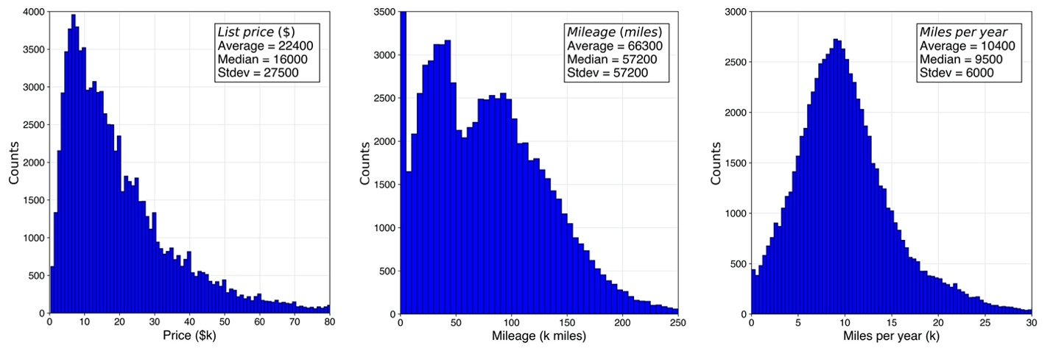

**Figure 1**. Histograms of (left to right) price, mileage, and miles per year across the 100,000 listings collected from Autotrader in January 2020.

Annual sport utility vehicles (SUV) sales exceeded those of sedans for the first time in 2014 (<https://www.edmunds.com/car-news/sedan-dethroned-as-most-popular-body-style-in-america.html>). This fact is already reflected in Autotrader listings, which show nearly 20% more SUVs than sedans (Figure 2, left). Together, SUVs and sedans make up more than half of cars on the market. On the other hand, the popularity of minivans has turned in the opposite direction: three times more popular in the year 2000 than they are today (<https://www.freep.com/story/money/cars/2019/08/02/minivan-sales/1898974001/>), minivans are beside station wagons at the bottom of the list.

Despite retaining just 10% of the US market, the truck segment lays claim to the most popular (by far) car in America, the Ford F-150 (Figure 2, right). The top ten most frequently encountered cars in this data set include four sedans (the midsize- and compact offerings of Camry, Accord, Civic, and Corolla from Toyota and Honda), four SUVs (Jeep’s Grand Cherokee and Wrangler alongside the Honda CR-V and Toyota Highlander), and two trucks (the aforementioned Ford F150 and Chevrolet Silverado 1500). One luxury offering made it into the top 20: the BMW X5.

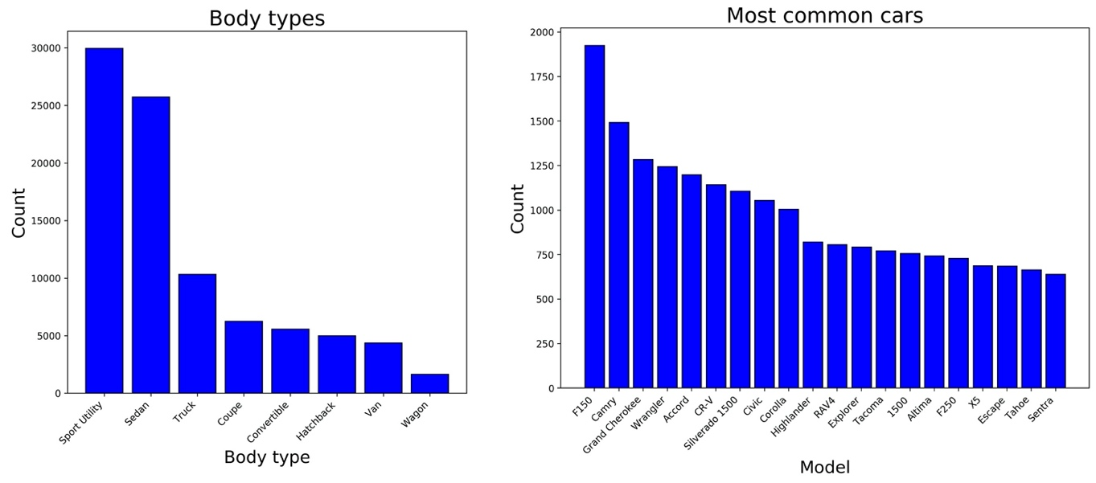

**Figure 2**. Bar plots showing number of listings by body type (left) and the most popular 20 models (right).

1. *Price modeling*
2. Price versus age and miles

With hundreds to thousands of individual listings collected for each of hundreds of car models, the evolution of price was evaluated across vehicle life cycle for each car model. For instance, Figure 3 shows approximately 1500 listings of the Honda Civic plotted in 3D, with x, y, and z-coordinates reflecting vehicle age, mileage, and price.

A surface of best fit was obtained by fitting an exponential regression against age and price of the form

*P*(*t*,*m*) = (*a*/2)·[exp(-*bt*) + exp(-*cm*)] + *d* (1)

Where price *P* is a function of age *t* and mileage *m.* The new car price is captured by constant *a*, while constants *b* and *c* are the decay coefficients against age and mileage, respectively. The bias term *d* represents the terminal value of the car. Because a typical scrap car commands less than $300 at the junkyard (<https://www.junkcarmedics.com/blog/scrap-car-prices-per-ton/>), this term was left out of the fit (i.e., *d* = 0).

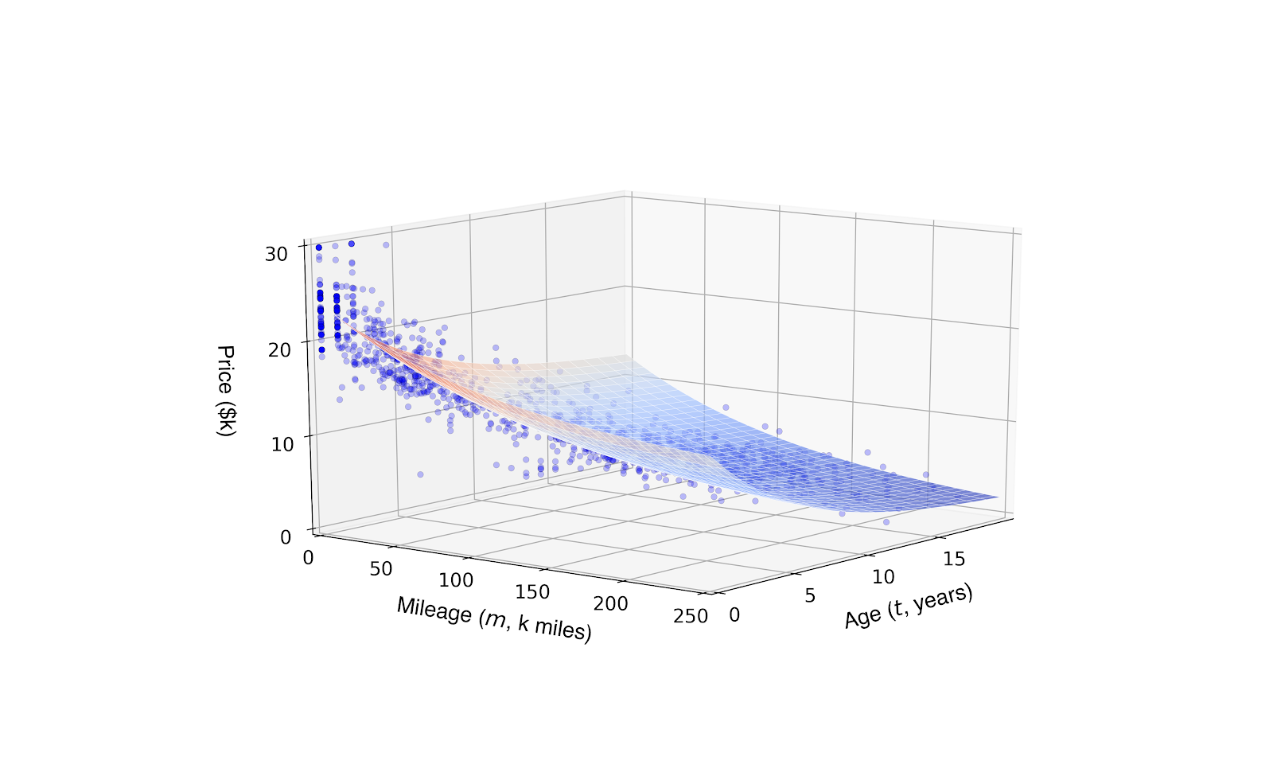

**Figure 3**. List price versus age and mileage for the Honda Civic (blue scatter data) and corresponding surface of best fit obtained from Equation 1.

1. Univariate analysis

For most car models, the surface of best fit described by Eq. 1 explains approximately 90% of the observed variance in price (*R*2 ≈ 0.90). When viewing the same 1500 listings in just two dimensions, either price versus age (Figure 4, left) or price versus miles (Figure 4, right), only a small sacrifice in fit quality (*R*2 ≈ 0.85) is observed.

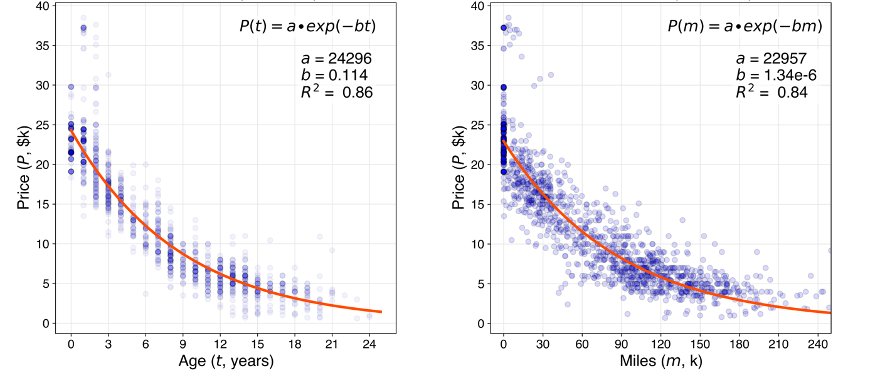

**Figure 4**. Scatter plot of price versus age (left) and price vs. mileage (right) across Honda Civic listings. The text inset describes exponential decay functions and resulting parameters from curve fitting. Note that empirical list price data is more tightly distributed around best fit line for model employing age as predictor of price.

In each case, fitting exponential decay functions of the form

*P*(*x*) = *a*·exp(-*bx*) (2)

with independent variable choice *x* (either age or mileage) allows for extraction of the typical new car price *a* and the decay coefficient *b*.

In the case of the Honda Civic, exponential fit of price vs. age (Figure 4, left) yields an estimated new car price of $24,300 and decay coefficient of 0.114 years-1.

One convenient aspect of modeling car depreciation with an exponential function is it lends itself to half-life (*t*1/2) calculation:

*t*1/2 = ln(2) / *b* (3)

where ln(2) ≈ 0.693 is the natural logarithm of 2 and *b* is the decay coefficient determined by exponential fit.

1. Model selection

While the model constructed with both vehicle age and mileage (Eq. 1) offers a slightly better fit quality than a univariate model (Eq. 2), the latter yields just one decay coefficient (*b*) instead of two (*b* and *c*), and thus offers a convenient single metric, or figure of merit, describing vehicle value retention.

Fit quality (*R*2) was then used to decide between age and mileage as the best univariate predictor of price. Across the most frequently encountered listings, age seems to do better than miles (Figure 5 left, blue versus orange bars). There is, however, a small subset of models that show the opposite trend. For cars such as the Ford Mustang, Chevy Camaro, and Dodge Challenger, age turns out to be a poor predictor of list price (Figure 5 middle). In these cases, there is a huge variation in price for the oldest models: while some may be on their way to the junkyard, others are trading hands for many multiples of their original MSRP. For cars with this sort of vintage appeal, it is difficult to estimate value and, as a result, depreciation rates.

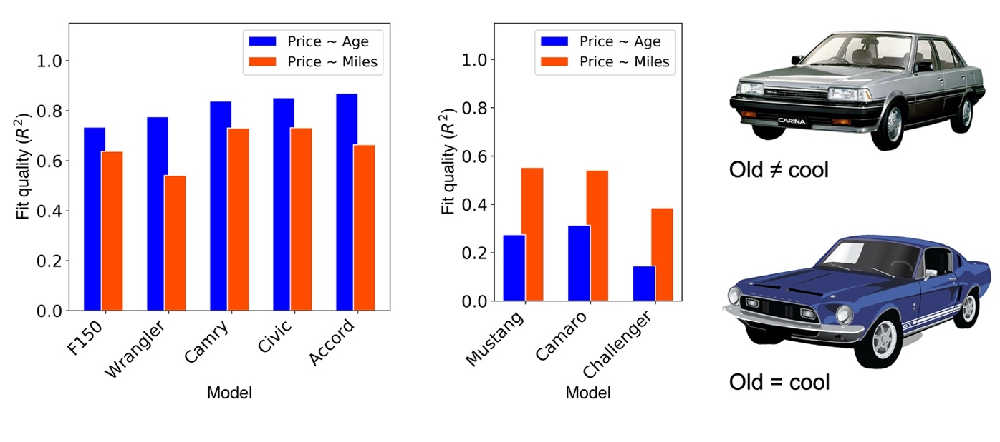

**Figure 5**. Bar plot showing comparison of fit quality using age or mileage (blue and orange bars, respectively) as univariate predictor of price for top five most common cars (left) and selected cars with vintage appeal (center). Note that vehicle age, typically the better measure of a car’s value, is a poor predictor of price for a few special cases where some of the oldest examples happen to be the most desirable.

1. *Depreciation analysis*
2. Outliers: best and worst in value retention

For each of several hundred make/model combinations present in the Autotrader dataset, listing data was fit according to Eq. 2 using vehicle age as the independent variable (Figure 4, left). Empirical depreciation curves for cars with a small number of observations (< 50 listings) or anomalous pricing (e.g., vintage appeal) typically yielded poor fit quality. To avoid drawing spurious conclusions from poorly understood pricing, a fit quality filter (*R*2 > 0.67) was applied.

Across 178 models with well-characterized pricing, the observed range of vehicle half-lives spans two to ten years, with most cars typically experiencing a five-year half-life (Figure 6, center). Among the fastest-depreciating cars are electric vehicles (EVs) and foreign luxury cars, while those that retain their value the longest are simple, mass-produced, and arguably iconic cars (Figure 6, left and right).

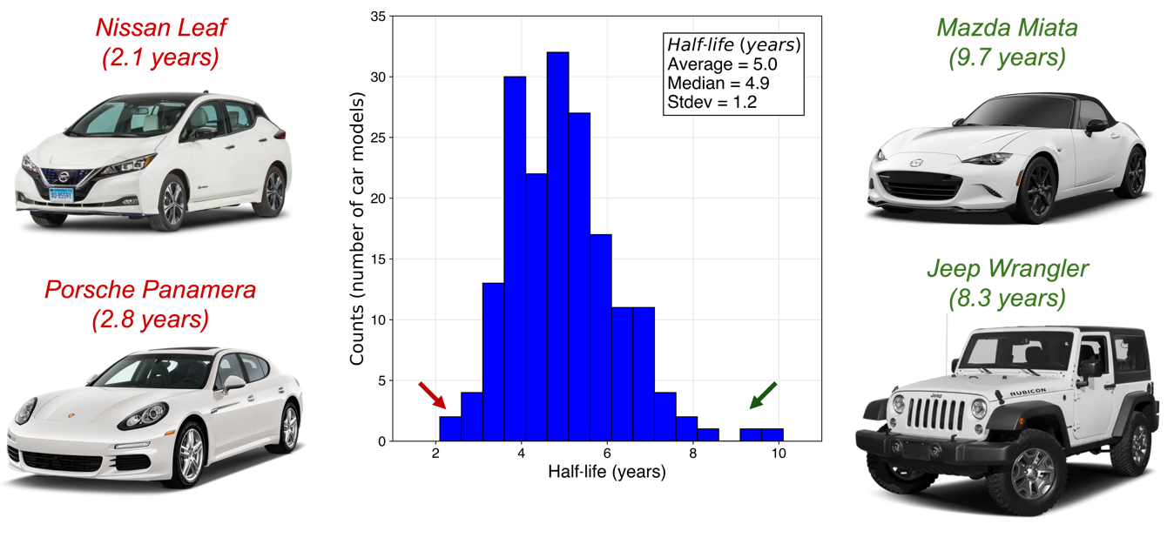

**Figure 6**. Histogram (center) displaying vehicle half-life estimates across 178 models. Each count was obtained by extracting the coefficient of exponential decay as shown in Figure 4 for hundreds (or thousands) of individual Autotrader listings for a particular model. Prototypical examples of quickly-depreciating and slowly-depreciating vehicles are shown at left and right, respectively.

Perhaps unsurprisingly, foreign luxury cars are close to the bottom of the list when it comes to value retention. One likely contributing factor is the high maintenance costs that accompany ownership of such cars (<https://www.businessinsider.com/10-cars-lose-the-most-value-last-5-years-2019-10>). In addition, the inevitable blemishes and dated appearance that used cars bring may be particularly undesirable to used luxury car buyers, who are almost certainly more image-conscious than the average buyer.

This analysis also indicates that the depreciation rate for EVs appears to be surprisingly harsh. Some of this effect may be artificial, since the $7500 Federal tax credit on the purchase of new EVs, which will be phased out over 2020 (<https://cleanvehiclerebate.org/eng/ev/incentives/state-and-federal>), is not available to used EV buyers and is thus immediately dropped off the used car sticker price. Even so, consumers seem to perceive EV technology as one that is advancing rapidly, and that used EVs may be by definition outmoded. In addition, range anxiety might be more pronounced in the used market: EV batteries begin to lose cruising range at 100,000 miles and may need replacement (at a cost upwards of $15,000) when the odometer approaches 200,000 miles (https://www.myev.com/research/ev-101/how-long-should-an-electric-cars-battery-last). Interestingly enough, it seems as though the Tesla brand might be a slight exception to the EV depreciation rule (<https://www.greencarreports.com/news/1123583_beyond-tesla-electric-cars-lose-value-faster-than-other-vehicles>), possibly related to the consensus that Teslas enjoy a more robust battery life, drivetrain, and sensors (<https://www.tesloop.com/blog/2019/2/6/tesla-and-the-electrifying-economics-of-depreciation>). In this analysis, half-life estimates of approximately five years for the Tesla Model S and Model X place them in the middle of the pack, although fit quality (*R*2 < 0.5) indicates this figure should be interpreted with some caution.

At the other end of the spectrum, the Mazda Miata and Jeep Wrangler (<https://www.roadandtrack.com/new-cars/g16345197/cars-with-slow-depreciation-that-hold-value/?slide=1>) are some of the best performers when it comes to value retention. These cars, and others that appear to retain their value well, are affordable, mass-produced, and have been in production for several decades.

Cars that perform the best in terms of value retention are shown in Table 1. This table displays, for a given make and model, the new price (extracted as fit parameter *a*, in dollars), the rate of decay (fit parameter *b*, with units years-1), the resulting half-life (calculated as ln(2)/*b*, in years), and the fit quality (*R*2 value, or fraction of observed variance that is explained by the model). Six of the top 10 cars for value retention belong to Japanese brands (Toyota, Nissan, Mazda, Honda), while the other four are American (Jeep, Ford, GMC). These cars typically lose half their value every 7 to 10 years, and are disproportionately entry-level or utility-focused.

**Table 1**. Top ten cars for value retention. 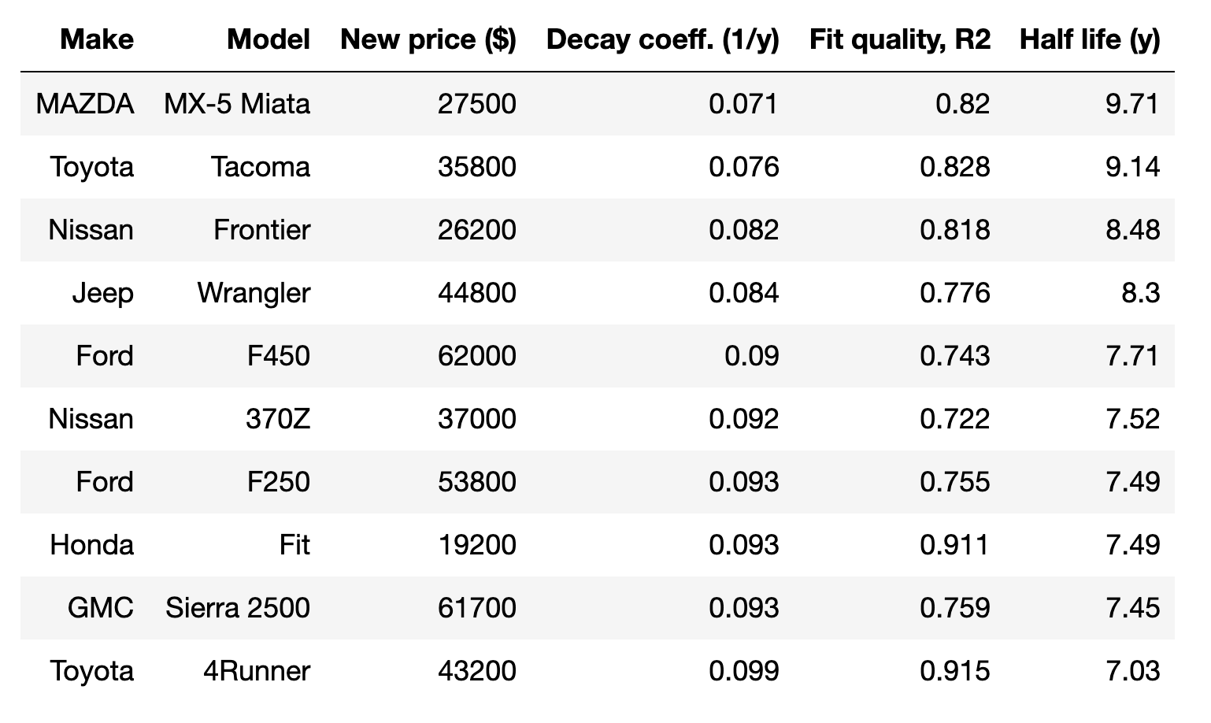

At the other end of the spectrum, cars that appear to lose value the quickest are shown in Table 2. Seven of the bottom ten cars for value retention are luxury offerings, and most of them are German (Porsche, VW, Audi, Mercedes). On average, these cars are twice as expensive as those appearing in Table 1, and two of the bottom four are EVs (the Nissan Leaf and VW e-Golf). Cars with poor fit statistics (*R*2 < 0.67) were excluded from both Tables 1 and 2.

**Table 2**. Bottom ten cars for value retention.

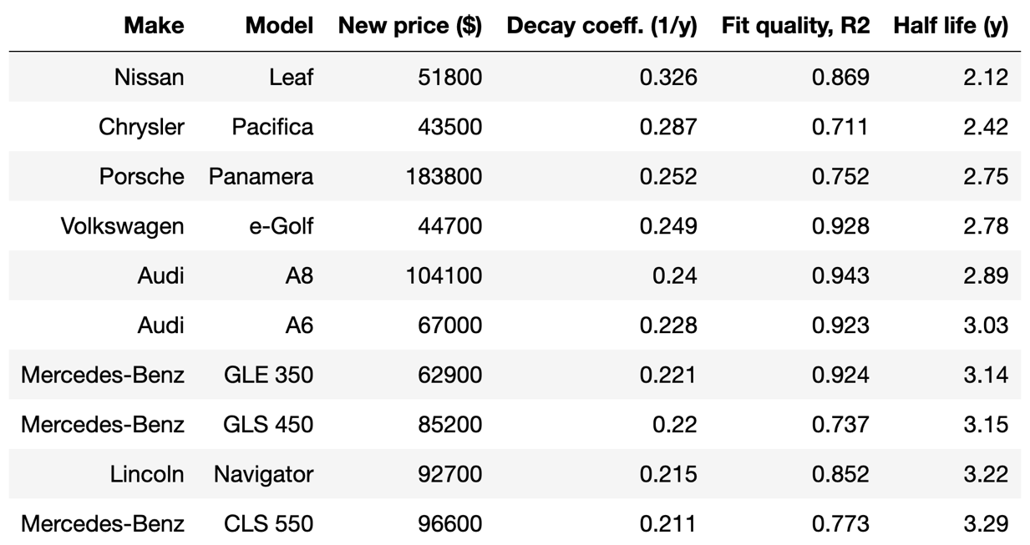

In striking contrast to those displayed in the previous table, these cars lose half their value every 2 to 3 years. To put this into perspective: a $50,000 car with seven-year half-life can be sold for $25,000 after seven years, while one with a three-year half-life is worth just under $10,000 after the same time interval. Put another way: choosing a slowly-depreciating car over a similarly-priced, quickly-depreciating one is, upon selling after seven years, equivalent to receiving into your bank account a transfer of 30% of the initial value of the vehicle.

(mention non-monetary component – pleasure/pain of ownership – can I point to specific problems with vehicles on this list and show that depreciation is taking this into account?)

1. Depreciation across car makes

Perhaps more interesting than comparing empirical depreciation rates across individual car models is looking at trends in the aggregated data across axes such as brand, body style, and location.

To this end, each of the 178 car models with well-characterized pricing (*R*2 > 0.67 for exponential fit of price versus age) was grouped by car make, and the corresponding half-life was visualized in a box plot (Figure 7). Across all brands, average half-lives span 3 to 6 years. Strikingly, the 10 brands that appear to lose their value the quickest are all in the luxury segment. Among luxury offerings, Lexus and Acura stand out with their solidly average half-lives of about 5 years. At the other end of the spectrum, 4 of the best 5 car brands for value retention are either Japanese or Korean. Hyundai and Toyota are at the top of this list, with all models (except for their luxury models, the Genesis and Avalon) showing half-lives above 5 years.

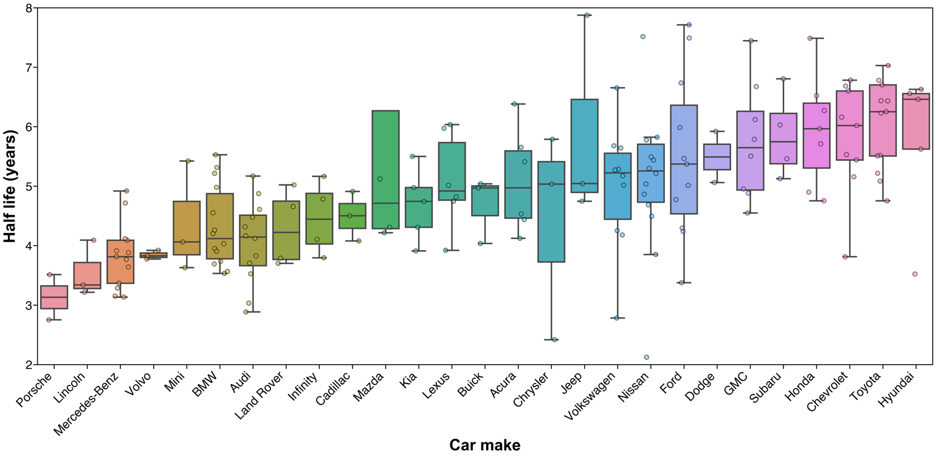

**Figure 7**. Comparison of depreciation rates, expressed in terms of half-life, across car brands. For each make, the colored box denotes the interquartile range (25th to 75th percentile), the line within it denotes the median value, and the whiskers encompass the remainder of the distribution minus outliers. Each scatter point represents, for a particular model, the decay coefficient resulting from exponential fit of hundreds or thousands of individual Autotrader listings.

1. Depreciation across body styles

Beyond car make, the influence of body type (coupe, sedan, SUV, truck, or van) on empirical depreciation rate was also explored. In this case, each of the 180 models with well-characterized pricing (*R*2 > 0.67) was grouped by body type, and corresponding half-lives were visualized in a box plot (Figure 8). Here, trucks clearly stand out for value retention. While SUVs, sedans, vans, and coupes all show median half-lives just under 5 years, trucks enjoy a nearly 6.5-year median half-life. Without knowing exactly why this might be, one might speculate that trucks retain their value better than other body styles due to: 1) tougher building materials results in comparatively reduced wear over a similar ownership period, 2) more conservative styling changes from year-to-year means that old trucks look less old than similarly-aged models in other segments, and 3) simpler use-case of trucks (hauling cargo in the bed) means that old and new trucks will perform similarly along this dimension.

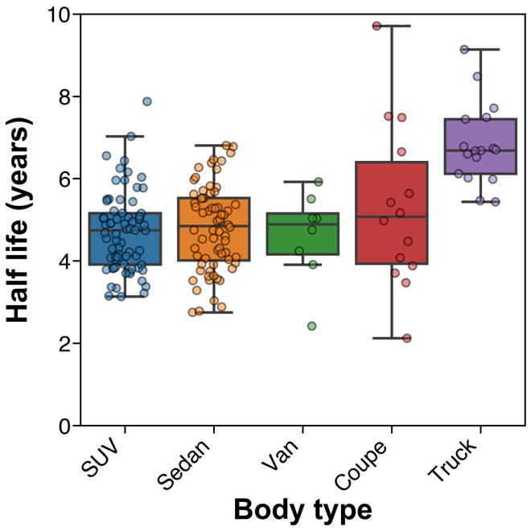

**Figure 8**. Comparison of vehicle half-lives across the five main body styles. Trucks appear to retain their value much longer than the others.

On the other hand, over the past couple of years, the American consumer is increasingly seeking out luxury offerings within the truck segment (<https://www.nytimes.com/2018/02/15/automobiles/wheels/luxury-trucks-suv.html>), often spending upwards of $70,000 on a Ford, Chevrolet, or GMC truck with premium aesthetics and new technology. As a result, to the extent that trucks are moving away from their historical role as the utilitarian choice, one might expect truck depreciation rates to be pushed down to be more in line with those of the rest of the market.

1. Depreciation across geographies

The influence of geography on observed vehicle depreciation rates was also evaluated. In this case, the top ten most frequently encountered models (F150, Camry, Grand Cherokee, Wrangler, Accord, CR-V, Silverado, Civic, Corolla, and Highlander) were split by geography, and exponential decay models were fit to each model-city pair.

*(delete?)*

A bar plot (Figure 9) showing half-lives by model and location reveals an average half-life of approximately 6 years across these top 10 common cars, highlighting that frequently encountered cars tend to hold their value better than comparatively rare ones. This plot also underscores the earlier observation that the Jeep Wrangler is a standout in value retention.

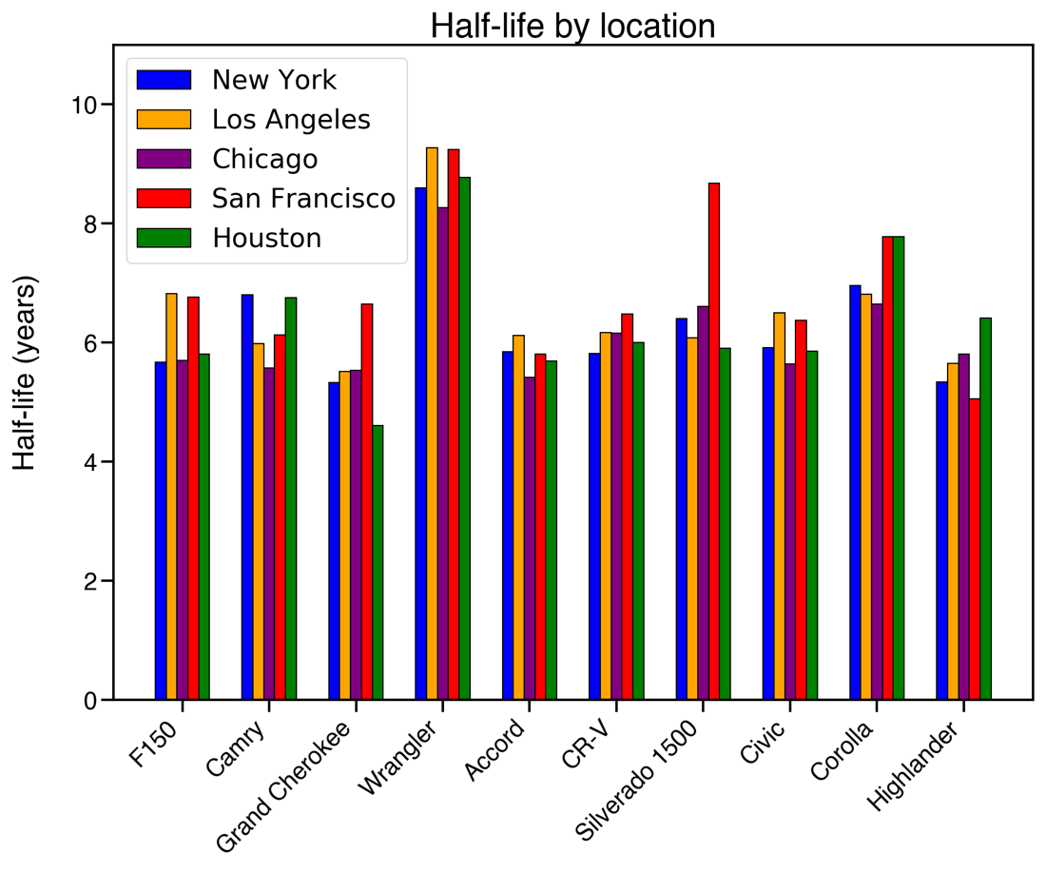

**Figure 9**. Empirical depreciation rates for top ten most frequently encountered car models in the Autotrader data set, split by listing location.

To elucidate geographic trends, scatter data from these models were grouped by listing location and corresponding half-lives were visualized with a box plot (Figure 10). Perhaps unsurprisingly, value retention for these selected cars scales inversely with seasonal temperature variation. For instance, these top ten most common cars experience a ~15% longer half-life in San Francisco (6.6 years) than they do in Chicago (5.8 years).

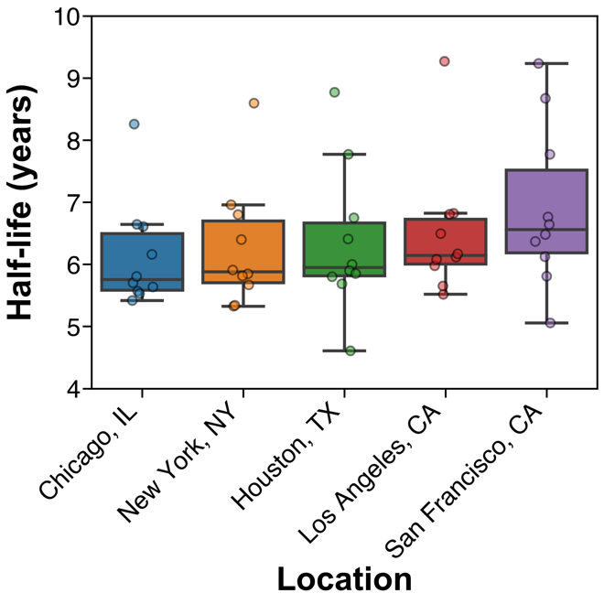

**Figure 10**. Effect of listing location on depreciation rate, binned by vehicle segment.

Given the additional exterior wear on cars driven in cold climates (salty roads increase paint abrasion, leading to rust), and the 45% increase in crash frequency in snowy weather (<https://www.ncbi.nlm.nih.gov/pmc/articles/PMC1449863/>), it may come as no surprise that the market applies a steeper markdown for cars listed in the Midwest than those coming from coastal California.

Also interesting is the possible discount applied to cars coming from hot climates. While snow is seen in Houston only slightly more often than in Los Angeles or San Francisco, Houston heats up much more in the summertime (average August high temperature of 95F) than the other two (84F and 68F, respectively). Sun and heat contribute to discoloration and cracking of the vehicle exterior and interior. In addition, engine oil and coolant, like all liquids, have higher vapor pressure at high temperatures. Cars routinely driven in hot climates are thus more susceptible to loss of these fluids, which can result in overheating, and in the extreme case, engine seizure (<https://www.holtsauto.com/prestone/news/hot-weather-car>).

1. Depreciation by time in production

Two leaders in value retention happen to be two of the oldest models on the market (the Jeep Wrangler and Mazda Miata, Figure 6), suggesting the possibility of a correlation between the time a vehicle has been in production and its depreciation rate. To evaluate this, the number of distinct model years with nonzero listing counts was used as a proxy for the number of years that a particular model has been in production. For each of the 178 models with well-characterized pricing, measured half-life was plotted against time in production (Figure 11). A reasonably strong positive relationship (Pearson’s *ρ* of 0.51) was observed between years in production and measured half-life, with the line of best fit implying that, on average, for every ten years of history an additional year is added to half-life.

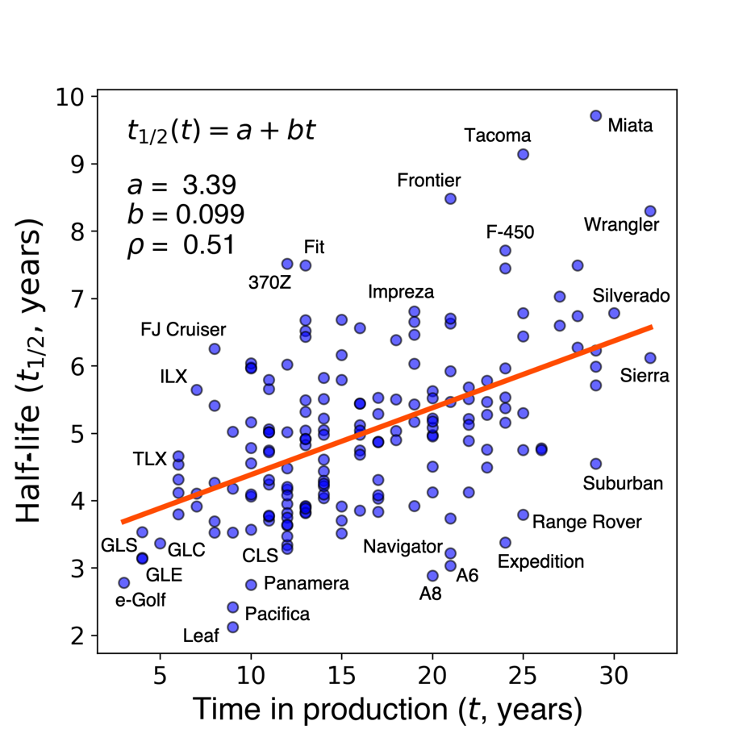

**Figure 11**. Scatter plot of time in production versus measured half-life for 178 cars with well-characterized pricing.

Beyond this general relationship, it’s interesting to note which cars deviate from the trend. While most new or short-lived models are generally not coveted by the market, the Toyota FJ cruiser appears to be on its way to collector status (<https://www.hagerty.com/articles-videos/articles/2017/10/31/toyota-fj-cruiser>). At the other end, while some established models like the Wrangler and Miata enjoy robust demand in the second-hand market, others like the Suburban and Range Rover appear to lose value more quickly than those with a similarly long history.

1. *Model validation*

A quick check of model performance can be run by comparing the best and worst performers (Tables 1 and 2) in value retention generated by fitting Autotrader listing data with automotive resources. There is remarkable overlap between the findings reported here (<https://www.iseecars.com/cars-that-hold-their-value-study#v=2019>).

1. General cases of prediction error

One might also wish to assess the choice of an exponential function (Eq. 2) to model the value of a car over its lifespan. This simple approach has a few key advantages: 1) the resulting fit parameters *a* and *b* are easily interpretable, 2) the decay coefficient *b* can be used as a figure of merit for value retention, and 3) with just 2 fit parameters, the regression converges quickly and is robust against overfitting.

To evaluate how well an exponential can approximate the observed list price over time, the prediction error was calculated for each of the 50 most commonly encountered models in the data set, for each of the last 20 years, according to the expression

Residual(age) = [ *P*obs (age) – *P*pred (age) ] / *P*obs (age = 0) (4)

where the difference between the average observed list price and the predicted price (*P*obs – *P*pred) is normalized by the observed new car price.

This residual was plotted for each of the frequently encountered models (Figure 11, grey traces), together with the average and 25th/75th percentile residuals across all models (red solid and dotted traces, respectively). In the ideal case, these traces would all be flat lines at zero, indicating perfect match between predicted and observed list price. In practice, however, the deviation of observed price from the prediction is often a few percent of the new car price.

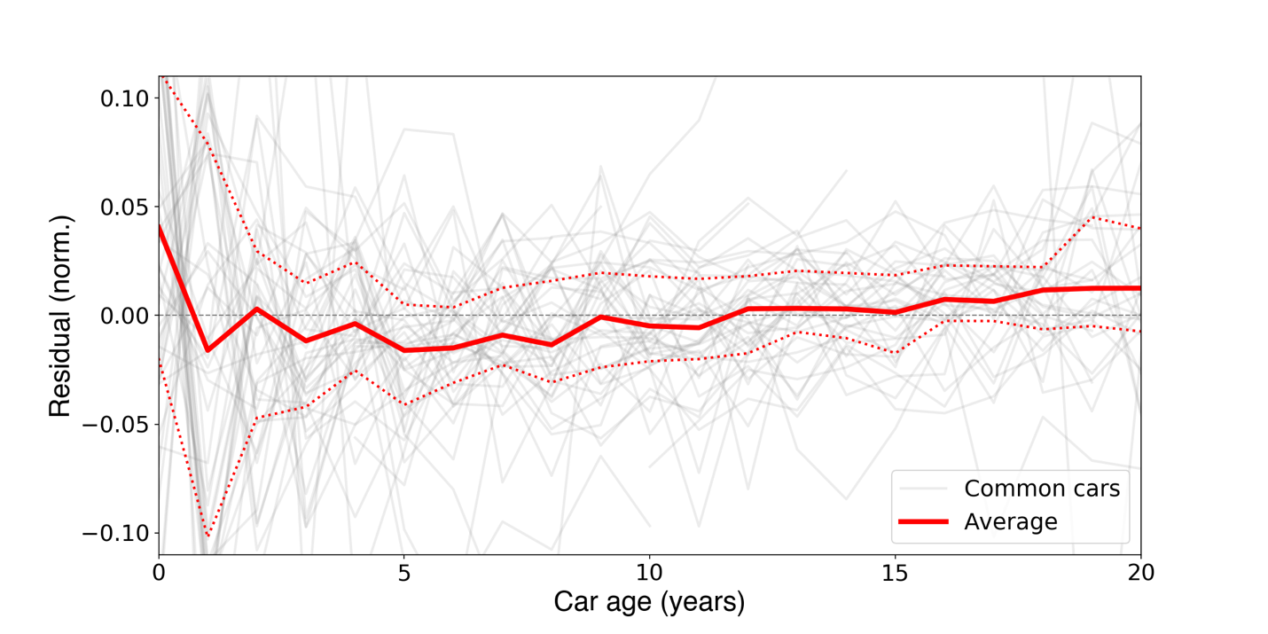

**Figure 12**. Difference between observed and predicted list price for 50 common cars (grey traces), along with average difference (solid red line) and 25th/ 75th percentile differences (dotted red lines) over two decades of vehicle ownership. Negative average values early on, and positive values later in the vehicle lifecycle, suggest that the true depreciation rate of a typical car is not constant but decreases slightly over time (d*b*/d*t* < 0).

Most interesting is the systematic deviation of observed prices from predicted prices when averaged across all cars. From the averaged data (red trace) it’s clear that exponential regression tends to underestimate new car prices: at year zero, the list price is about 4% higher than the predicted price, while for one-year-old cars, the list price is nearly 2% lower than the predicted price. This implies that new cars, on average, depreciate about 6% faster in their first year than indicated by the exponential model, and supports the idea that car depreciation is maybe best expressed as a piecewise function (<https://www.free-online-calculator-use.com/car-depreciation-calculator.html>), splitting the first year from the rest of the vehicle lifespan.

Similarly, the negative residual between years one and ten suggests that newer used cars depreciate more quickly than the exponential best fit model would predict. At the other end, towards the end of life (age > 15 years), average list prices consistently exceed the predicted price, implying that depreciation slows for older cars. The true rate of depreciation for a typical car is not constant, but varies slightly across its life. A more sophisticated model of car value over time might fit individual segments of the vehicle life cycle or allow for the exponential decay coefficient *b* in Eq. 2 to itself be a function of vehicle age.

The quick depreciation during the first year and its slowing after 15 years can be seen in the canonical case of the Jeep Wrangler (Figure 12). The observed price drop from years 0 to 1 is much steeper than what’s implied by the line of best fit. This discontinuity between first-year depreciation and that of subsequent is perhaps unsurprising, given the car’s abrupt transition from “new” to “used” when the odometer loses some of its zeros. At the other end of the ownership lifecycle, most listings of 20+ year old Wranglers are priced above the prediction line. From this it’s clear that depreciation on senior cars (particularly if they have vintage appeal, see Figure 5) is also somewhat different from earlier in its life.

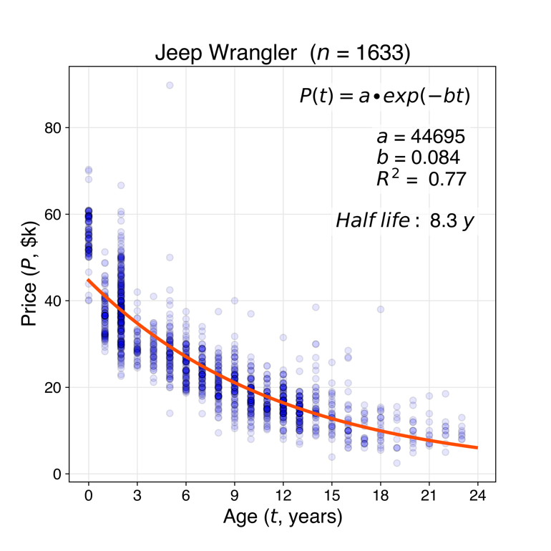

**Figure 13**. List prices for 1633 examples of the Jeep Wrangler listed on Autotrader as of January 2020 (blue scatter data) and resulting exponential curve of best fit for price versus age (orange trace). Deviation between observed and predicted price at year zero and years 15+ illustrate the principle limitation of this simple exponential decay model.

1. Price discontinuity across a model redesign

So it’s clear that the exponential function might underestimate depreciation in year 0 and overestimate depreciation in years 15+ (Figures 11, 12). One other failure mode of this simple exponential price model involves price discontinuities across significant redesigns of a particular car. The Porsche 911 offers perhaps the most striking example of such a phenomenon (Figure 13). In 1998, the “993” version of the 911, which is referred to by enthusiasts as the “best and most desirable of the 911 series,” and the “last modern classic” (<https://en.wikipedia.org/wiki/Porsche_993#Media>) was replaced by the “996” version. Spurred by Porsche’s financial troubles in the late ‘90s, the “996” 911 borrowed many components with the more economical Boxster cousin. As a result, the market values 911s from 1999 far below ($21,000 average price) the 1998 production year ($57,000). In such cases, eyeballing the scatter data itself can be more informative than referring to an extracted half-life measurement.

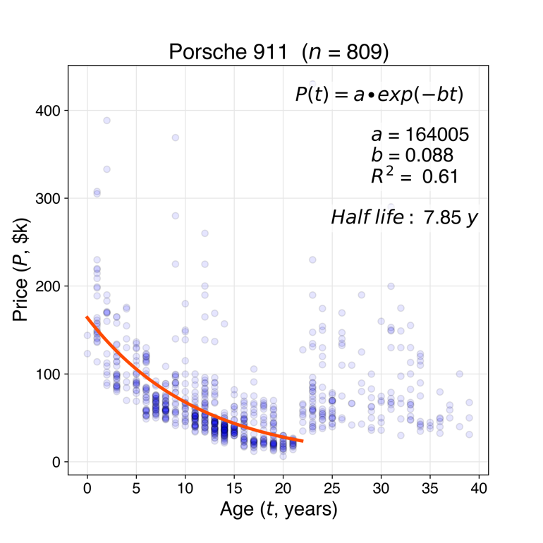

**Figure 14**. List prices for 809 examples of the Porsche 911 listed on Autotrader as of January 2020 (blue scatter data) and resulting exponential curve of best fit for price versus age (orange trace), excluding vehicles older than 22 years. The discontinuity in list prices at year 22 points to a special case of the limitation of using this simple exponential decay to model car prices over time.

1. Rare/collectible models

The Toyota FJ Cruiser was introduced in the US in 2006 and phased out in 2014 due to poor sales. While Jeep sold 230,000 Wranglers in the US last year, Toyota sold about that FJs across all 8 years of its production. Perhaps because of this relative scarcity, and the collector status of its older FJ40 cousin, many used FJ Cruisers are now trading hands for upwards of 90% of their new price (<https://www.hagerty.com/articles-videos/articles/2017/10/31/toyota-fj-cruiser>). For this reason, the FJ Cruiser is another edge case for depreciation modeling (Figure 14). An unconstrained exponential fit yields a new price of $58,000 and half-life of 6.3 years, while fixing the new price at the inflation-adjusted median sale price of the 2014 model ($35,500) produces a record-setting half-life estimate of 12 years. In such cases, there may be a speculative component to pricing, whereby buyers are making offers with the perception that the vehicle might actually appreciate under their ownership.

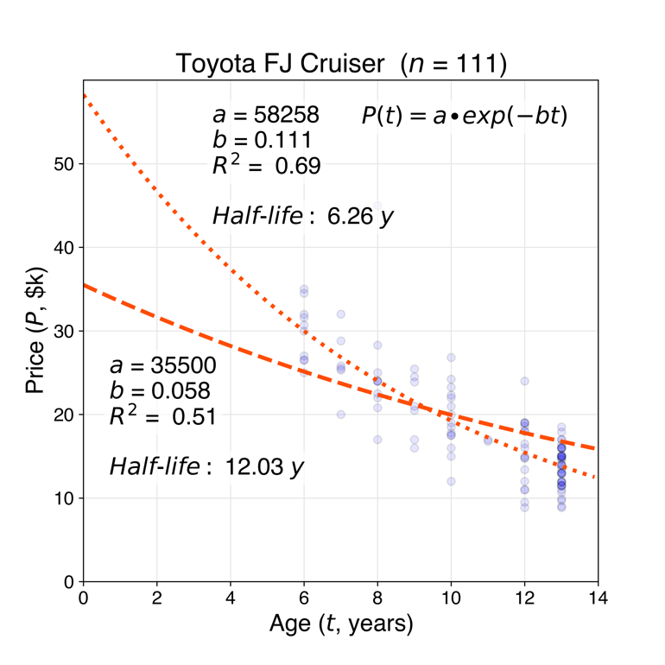

**Figure 15**. List prices for 111 examples of the Toyota FJ Cruiser (blue scatter data) and resulting exponential curve of best fit for price versus age (orange trace).

**Conclusions**

* 100,000 Autotrader listings scraped in January 2020
* The observed list price was fit to an exponential versus car age to obtain empirical depreciation curves for each make/model combination
* The vehicle half-life was extracted from coefficient of exponential decay, used as a simple measure of how well a particular car retains its value
* The ends of the distribution were examined – electric vehicles and foreign luxury cars typically lose their value the fastest, while cars that have some sort of iconic or utilitarian appeal typically retain their value the longest
* Binning empirical depreciation rates by car make, the ten brands losing their value the fastest all belong to the luxury segment, and four of the top five for value retention are Japanese or Korean
* Trucks retain their value longer than other body styles, and depreciation rates are faster for vehicles listed in areas with large seasonal temperature variation
* On average, the exponential pricing model tends to underestimate the rate of depreciation for newer cars and overestimate it for older cars – true rate of depreciation is not constant but varies across the life of a car
* Guiding principles for frugal car buying
  + Cars lose a lot of value in year one – a typical one-year-old car has ~95% of its life remaining but sells for 75% of its new price
  + Luxury cars and electric vehicles tend to depreciate quickly. In terms of value retention, Lexus, Acura, and Tesla are above average.